Camplite kitchen sink upgrade
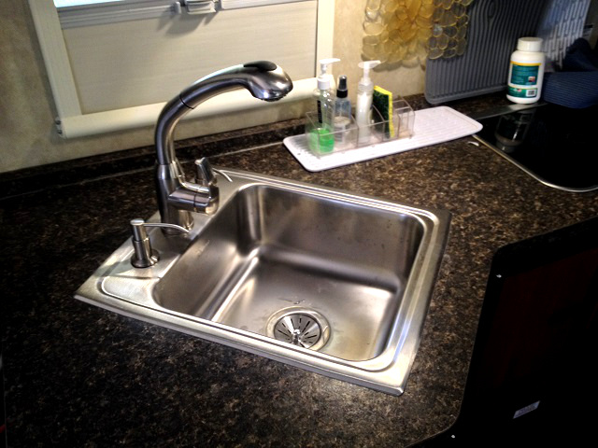SINK 1 PIX
I’ll call this my Golielocks sink upgrade. Tinkeringtechie’s choice was a little too small and Gleamb’s choice was a little too big so I went down the middle and it’s just right. The Elkay 17x20 inch stainless sink fits perfectly in the 21RBS. It should also fit the 21BHS and 28BHS, but maybe not the 16s.
After outlining the new cutout with painter’s tape and measuring, re-measuring, re-measuring, re-measuring, and re-measuring again the cut was easily made with a fine tooth scroll blade in a jigsaw.

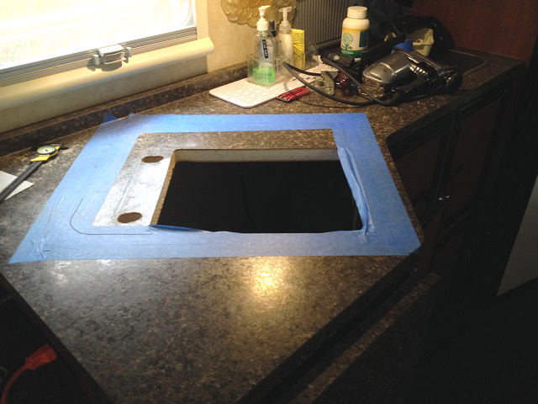SINK 2 PIX
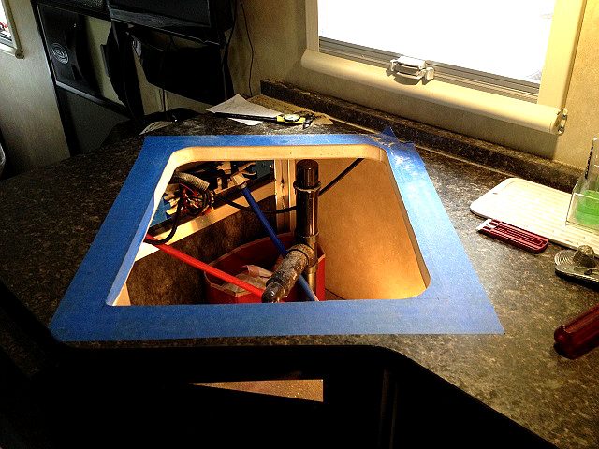SINK 3 PIX
The drain stack was rebuilt with a new P-trap and sanitary Tee to accommodate the deeper sink. zThe sink flange was sealed into the counter top with Butyl tape.
The hardest part was tightening the U-channel clamps while working in the limited access space. It took me a while to realize that three screws would remove the cabinet door. Lots easier!
The supply lines were connected using ½” x ½” plastic compression PEX fittings. Note the threads must be BSP or BSPP, not NPT.
My wife and chief dishwasher is thrilled with the larger sink and reduced splashing. Now we don’t have to wash dishes after using just two mugs and two plates.
Here are the major parts required:
http://www.amazon.com/Elkay-PSR17203-Gourmet-Pacemaker-Stainless/dp/B00084SHEY/ref=sr_1_2?ie=UTF8&qid=1430138107&sr=8-2&keywords=elkay+psr1720
http://www.amazon.com/Elkay-LK364-Extra-Long-Screws/dp/B000HBFCE6/ref=sr_1_1?ie=UTF8&qid=1429969298&sr=8-1&keywords=elkay+364
http://www.amazon.com/Elkay-LK35-Stainless-Strainer-Tailpiece/dp/B00128C4TY/ref=sr_1_1?ie=UTF8&qid=1419005678&sr=8-1&keywords=elkay+lk35
http://www.amazon.com/Dura-Faucet-DF-NMK861-VB-Hi-Rise-Pull-out/dp/B00HYIBJR4/ref=sr_1_11?m=ATN6X3LNWFD5C&s=automotive&ie=UTF8&qid=1430066548&sr=1-11&keywords=dura+faucet+rv
http://www.amazon.com/gp/product/B001FODIAO/ref=oh_aui_search_detailpage?ie=UTF8&psc=1&tag=viglink24002-20
http://www.amazon.com/Dicor-BT-1834-1-Butyl-Seal-Tape/dp/B001FCB4JS/ref=cm_cr_pr_product_top?ie=UTF8

